**Knox Makers Backlit Badge V1 Kit Instructions**

March 2019

We usually assemble circuit boards starting with the lowest profile components and work our way up to the taller, higher profile components. As you work, refer to the component list and circuit board photos for values and visual guides.

**Start with the resistors**

With this circuit board, like most, we’ll start with the resistors. Resistors are usually labeled on schematics and circuit boards as R1, R2, R3, etc. Resistors are not polarized components so they can be inserted with either end in either hole. They are typically labeled one of two ways.

Most common is color codes: Sometimes letter and digit codes can be found:

|  |  |
| --- | --- |
| **Resistor Value** | **Marking** |
| 200Ω, 1% | 2000F |
| 1,000Ω (or 1kΩ), 1% | 1001F |
| 10,000Ω (or 10kΩ), 1% | 1002F |
| 121,000Ω (or 121kΩ), 5% | 1213F |

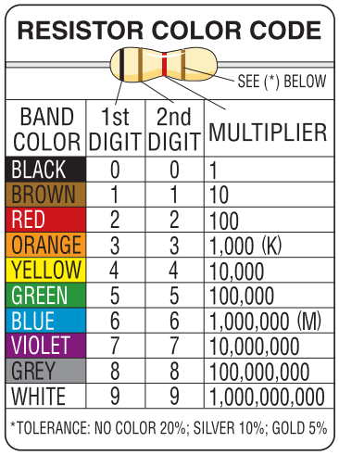

For each resistor, R1-R17, find the appropriate value resistor, bend its leads 90 degrees, insert the resistor from the front and bend the leads outward on the back to hold it in place. For resistors with digit codes, bend the leads such that the digit code is visible after assembly. Resistors should sit fairly flush with the circuit board and should hold in place when the circuit board is upside down.

You might find it helpful to go ahead and solder the resistors in place and trim the leads on the back flush so they aren’t in the way of the next components.

**Now the two capacitors**

Sometimes capacitors are polarized but in this kit we used non-polarized capacitors so it doesn’t matter which lead goes in which hole. Physically smaller capacitors like these are typically labeled with numbers, examples are in the table below. Place C1 and C2, C3 is not needed and not included in the kit.

|  |  |
| --- | --- |
| **Capacitor Value** | **Marking** |
| 100pF | 101 |
| 1,000pF (1nF, 0.001µF) | 102 |
| 10,000pF (10nF, 0.01µF) | 103 |
| 0.1µF | 104 |
| 0.22µF | 224 |
| 1µF | 105 |
| 10µF | 106 |

**The 90° header pins**

The header pins are labeled J1 on the circuit board. It can be tricky to keep them positioned while you solder them from the back. You might try holding them in place while soldering them but be sure to put something between your fingers and the pins as they will get very hot very quickly.

**Add the transistors**

Like LEDs, transistors are polarized and must be inserted correctly. Match the flat side of the body of the transistor to the flat side on the silk screen on the circuit board. The leads may need to be bent out some to match the spacing of the holes in the circuit board. They aren’t that delicate and can be bent readily. Make sure you get the transistors fairly close to the board (not flush, but within 0.1” or so) or they will later force the backlit cover farther from the LEDs.

**Coin Cell Battery Holder**

The coin cell holder mounts on the back of the circuit board. The circuit board has a black solder mask layer that will cause a small gap between the battery and the square pad it needs to make contact with. You need to build up a very thin mound of solder on that pad. You know there’s enough if you hold the battery against the mound and it just barely rocks back and forth on it. Now you can mount the coin cell holder.

**Finally the LEDs**

LEDs are a type of diode and all diodes are polarized with one lead being the anode and one being the cathode. The circuit board has a label “A” by the hole in which the anode (the longer lead on the diodes) should be inserted.

Note that D9 gets special treatment. It’s located opposite the battery so it can’t poke through the board. You’ll have to cut the leads short, give them a small bend on the end and solder it to the pads that it attaches to. See the associated picture. Be sure to keep track of which lead is the anode in this process. One method is to maintain one lead longer than the other.

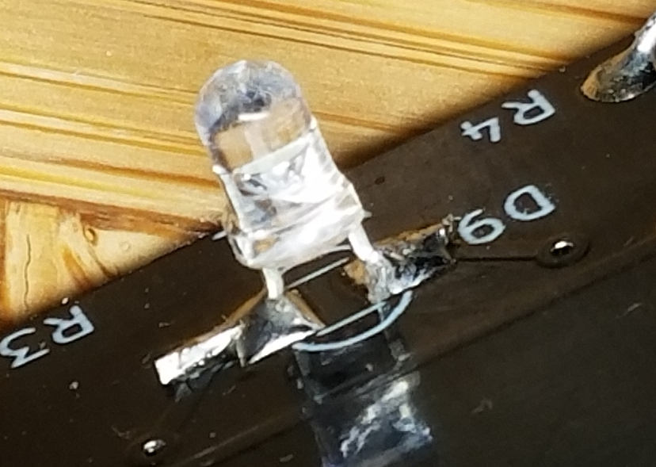

It’s common to accidentally install an LED or two backwards. You might proceed to the test/debug stage to make sure all your LEDs are lighting up before you solder and trim them. They are easy to fix now but much more difficult once soldered in place.

**Test and debug**

Slide the coin cell battery into its holder with the plus side up (making contact with the tabs on the cage). Place the jumper across the header pins, shorting them out and turning the badge on. You should see all the LEDs blinking.

If nothing is working then make sure the battery isn’t backwards, make sure the jumper is pressed down across the header pins and visually inspect all the solder joints.

If one or two LEDs aren’t blinking they were probably soldered in backwards or the resistors connected to them are the wrong value.

If D1-D6 aren’t blinking but D7-D11 are then check that Q1 is inserted correctly and R12 is the correct value.

If D7-D11 aren’t blinking but D1-D6 are then check that Q2 is inserted correctly and R13 is the correct value.

If the LEDs are blinking very fast then check that R15 and R16 are the correct values. Higher values make it blink slower, lower values blink faster.

**Add the backlit cover**

The cover is held in place using 4 header pins, one in each corner. These pins need to be soldered such that they are perpendicular to the circuit board or they may not align with the cover. This is a little tricky, you may need to play around to see what works for you.

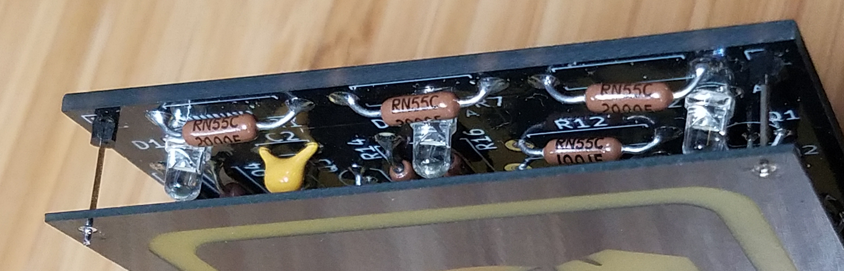

One method is to solder a pin in place but let it be crooked. Then remelt the solder while you push on the plastic base of the header pin with a fingernail to press it flat against the circuit board. You might come up with your own method you like better.

Once the 4 pins are soldered onto the circuit board place the cover over them and press it down as fast as it will go. Make sure you like how it’s visually placed, solder the pins to the backlit cover board and trim them flush.

Congratulations, you did it!

**Theory of Operation**

The backlit badge blinks 11 LEDs that are divided into two banks, 6 in one, 5 in the other.

Q3, Q4 and their associated components (R14-R17, C1, C2) form an oscillator. R15, R16, C1, C2 determine how fast the circuit oscillates. If you reduce the resistors by ½ then the circuit will blink at roughly double the speed. The capacitors will do the same.

Q1 and Q2 are connected to opposite sides of the oscillator, turning them on and off alternately. When Q1 is turned on it allows current to flow through D1-D6, illuminating them. When Q2 is turned on it allows current to flow through D7-D11, illuminating them.

J1, the right angle header pins, are just a poor man’s switch. When a jumper is connected across them it energizes the circuit by making the connection from the battery to the rest of the circuit.

**Bill of Materials**

|  |  |  |
| --- | --- | --- |
| **Qty** | **Designator** | **Item** |
| 1 | - | PCB |
| 1 | - | PCB-Cover |
| 4 | - | Header Pins, straight, 0.5" long? |
| 1 | J1 | Right Angle header pins, 0.1" spacing |
| 1 | - | CR2032 Coin Cell Holder, Keystone 3035 footprint |
| 1 | - | CR2032 Battery |
| 4 | Q1-Q4 | 2N3904, TO-92 |
| 11 | D1-D11 | LEDs, 3mm, white |
| 11 | R1-R11 | 200 Ohm resistors, 12.7mm lead pitch |
| 2 | R15, R16 | 121k Ohm resistors, 12.7mm lead pitch |
| 2 | R14, R17 | 10k resistors, 12.7mm lead pitch |
| 2 | R12, R13 | 1k resistors, 12.7mm lead pitch |
| 2 | C1, C2 | 10uF nonpolarized capacitors, 5.0mm lead pitch |
| 0 | C3 | Do Not Place |

